Project Development - Database design

Useful Links:

1. <https://docs.google.com/document/d/1OzVG3b9UYPqUFS35BZhbm6AAXslOX01Ztm6IjBX1Ko0/edit>
2. <https://remotemysql.com/>
3. <https://www.freesqldatabase.com/freemysqldatabase/>

# MySql Introduction and Queries

1. When you statement in databases can be represented as Query

## Create the Database:

Used to create the database

Syntax: create database [If Not exists] databaseName

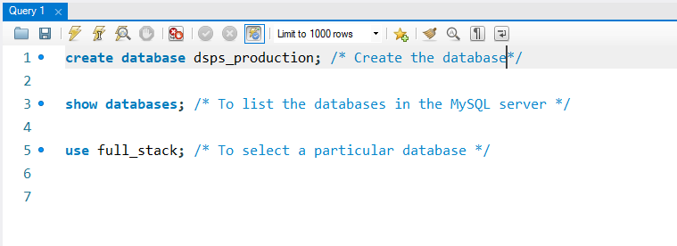

## Create the Table:

Syntax: create table Table_Name(

Col_1_defination,

Col_2_defination,

Col_3_defination

………………...

);

1. The ciolumn_name specifies the name of the column or attribute. Each column has a specific data type(char,varchar,integer,date,time,datetime…..)
2. Constraint : NOT NULL, Check, Unique, Primary Key and Foregin Key
   1. NOT NULL : Then the column does not allows the NULL values
   2. Check : Used to define the condition on the column
   3. Unique : Used to stop duplicate values
   4. Primary Key : Combination of Not null and Unique
   5. Foregin Key : Is used maintain the relationship between two tables

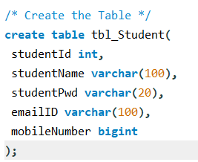

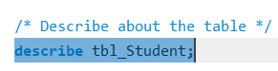

## Insert the Data to the table:

By using insert query we can insert the records or tuples into the table

Syntax: insert into Table_Name(col1,col2,col3….) values (v1,v2,v3….)

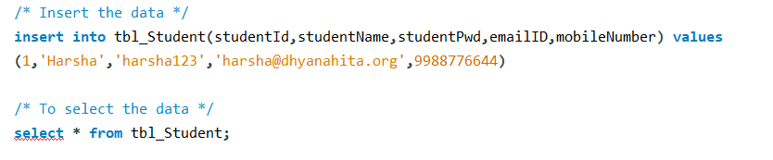

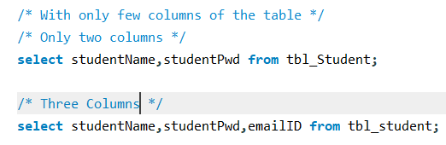

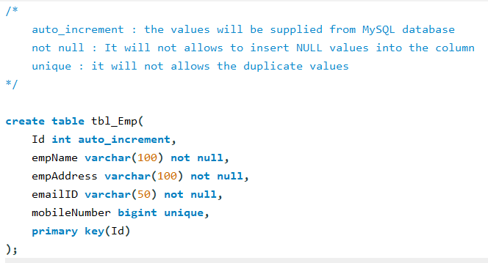

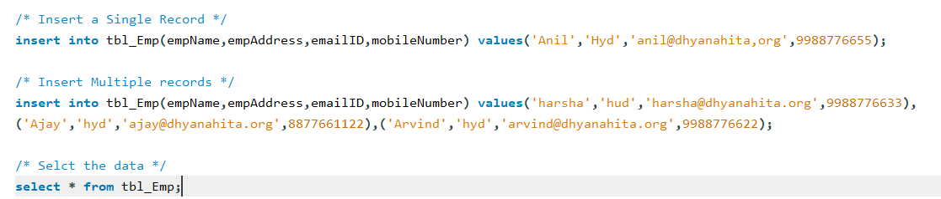

## Update the Data:

Syntax: Update table_name set Col_name = Val1, Col_name = Val2 …..[where clause]

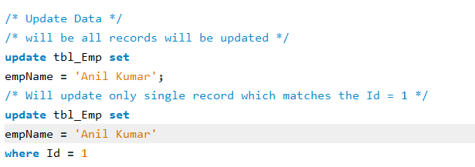

## Delete the Data:

Syntax: delete from Table_name [where Condition];

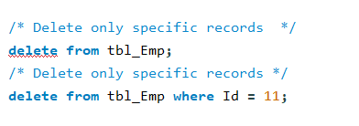

## Select the Data (Read the Data):

The select statements allow you to read the data from one or more than one table.

Syntax: select * from tableName or

Select ColList from tableName;

## Select Data (Sorting Data)

Order by clause allows you to sort the selected data

Syntax: select Select_list from tablename order by columName[ASC|DESC]

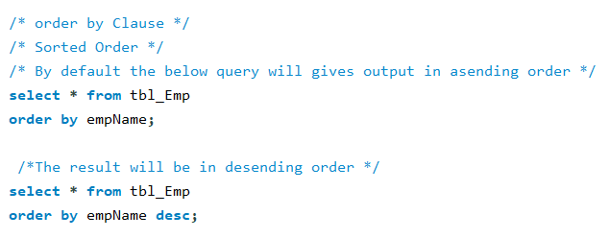

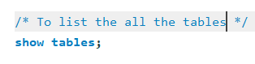

# Sample Database : http://tiny.cc/Sample-Db

Download from the above link and extract on your computer. After you will get the file as mysqlsampledatabase and Open file by double clicking.